EXPT NO:4A | EXPLORATORY DATA ANALYSIS (EDA) – DATA  INSPECTION, FILTERING, STATISTICAL  ANALYSIS AND CORRELATION

Aim:
To perform data inspection, filtering, grouping, aggregation, descriptive statistical analysis, and correlation analysis using Pandas and visualize the results using Matplotlib.
Algorithm:
- Import the required Pandas, NumPy and Matplotlib libraries.
- Read the stud_data.csv file using Pandas.
- Display the dataset and inspect the first few records.
- Find the number of rows and columns and display the data types.
- Generate the statistical summary of the dataset.
- Filter the students based on marks and attendance conditions.
- Sort the student records based on marks and attendance.
- Group the data based on department and calculate average marks and attendance.
- Calculate mean, median, minimum, maximum and standard deviation of marks.
- Calculate the correlation between marks and attendance.
- Create bar chart, line chart, scatter plot, histogram and box plot using Matplotlib.
- Display the results and interpret the obtained data.
Program:
import pandas as pd import numpy as np
import matplotlib.pyplot as plt

df = pd.read_csv("stud_data.csv")

# Display dataset print(df)

# Display first five records print(df.head())

# Display shape print(df.shape)

# Display data types print(df.dtypes)

# Display statistical summary print(df.describe())

# Filter students with marks greater than 80 print(df[df["Marks"] > 80])

# Filter students with attendance greater than 90 print(df[df["Attendance"] > 90])

# Sort students by marks print(df.sort_values("Marks", ascending=False))

# Sort students by attendance print(df.sort_values("Attendance", ascending=False))

# Department-wise average marks print(df.groupby("Department")["Marks"].mean())

# Department-wise average attendance print(df.groupby("Department")["Attendance"].mean())

# Calculate mean

print("Mean Marks:", df["Marks"].mean())

# Calculate median

print("Median Marks:", df["Marks"].median())

# Calculate minimum

print("Minimum Marks:", df["Marks"].min())
# Calculate maximum

print("Maximum Marks:", df["Marks"].max())

# Calculate standard deviation

print("Standard Deviation:", df["Marks"].std())

# Display correlation matrix print(df[["Marks", "Attendance"]].corr())

# Display correlation between marks and attendance print("Correlation:", df["Marks"].corr(df["Attendance"]))

# Bar chart

plt.bar(df["Name"], df["Marks"]) plt.title("Student Marks") plt.xlabel("Name") plt.ylabel("Marks")
plt.show()

# Line chart

plt.plot(df["Name"], df["Attendance"], marker="o") plt.title("Student Attendance") plt.xlabel("Name") plt.ylabel("Attendance")
plt.show()

# Scatter plot plt.scatter(df["Attendance"], df["Marks"]) plt.title("Marks vs Attendance") plt.xlabel("Attendance") plt.ylabel("Marks")
plt.show()

# Histogram plt.hist(df["Marks"], bins=5) plt.title("Marks Distribution") plt.xlabel("Marks") plt.ylabel("Number of Students") plt.show()

# Box plot plt.boxplot(df["Marks"]) plt.title("Marks Box Plot") plt.ylabel("Marks") plt.show()
Output:

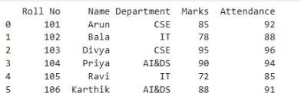

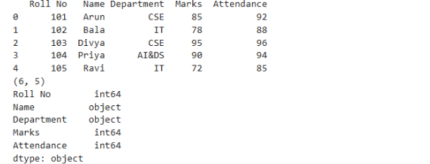

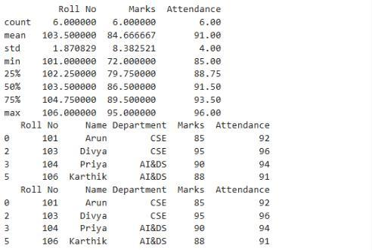
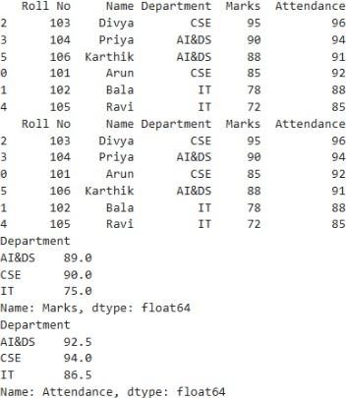

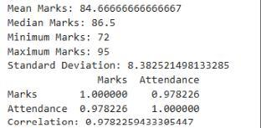

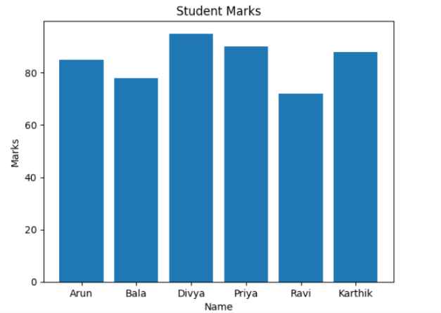
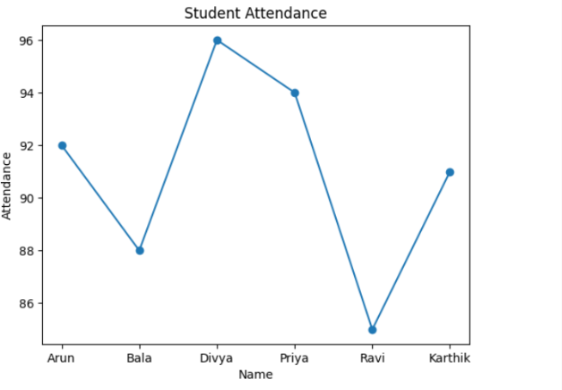

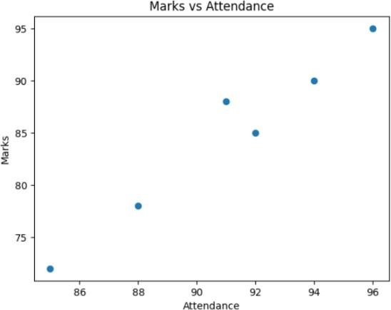
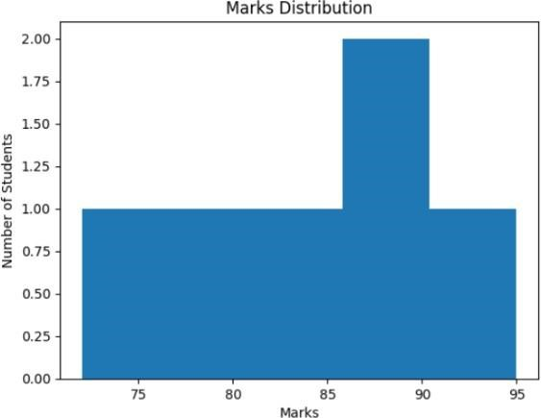

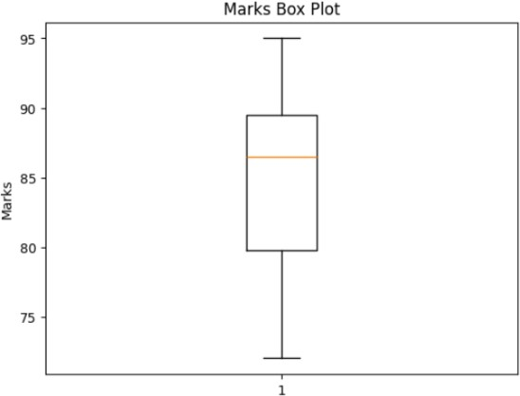
Result:

